Quiz 1: System Software – Day 4

**Active Directory**

**Active Directory**

1.What is Active Directory?

A.It stores information about members of the domain, including devices and users

B.Microsoft’s network directory service and is the method used to create a domain.

C.It allows you to view all the steps and review the detailed results during the installation process

D.The default protocol used in directory services

2.Active Directory was first introduced with the release of Windows ______

A.2000

B.Server 2012

C.7

D.XP

3.These are the componet for Active Directory infastructure "except"

A.Domains

B.Groups

C.Forest

D.Domain trees

4.What is AD Domain Trees?

A.A group of domains that share the same root namespace

B.Collection of one or more domain trees sharing the same Global Catalog and schema

C.Used as a central repository of networked device information for querying, updating, and authenticating against the data

D.A tree

5.If Active Directory isn’t running, you still can use Group Policy

A.True

B.False

6.Which one is true ?

A.Computers- Account objects stored in the AD database

B.Built-in containers - Provide for a logical hierarchy within the domain

C.Servers - Represent individual computing machines on the network

D.Groups - managed as a collective instead of as individuals

7.

7. What is this?

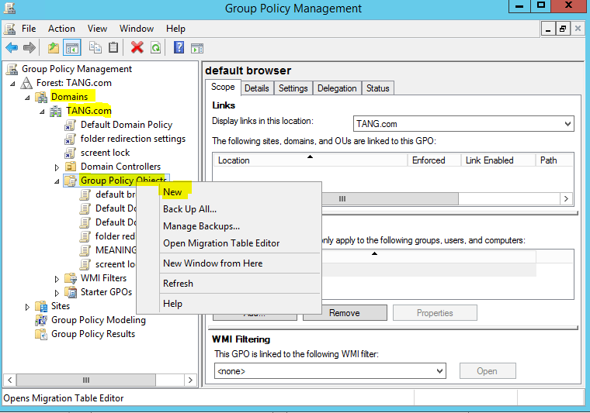

A.DNS

B.GPO

C.Task Manager

D.Network And Sharing Center

8.What will happen when the administrator stop solitaires from running?

A.Continue running

B.Transform to Valorant

C.Can't running it

D.Nothing happen

9.

GPO is provide centralized management and configuration of OS

A.True

B.False

10.

These are the advantage of Active Directory except ?

A.Increased scalability

B.Easy to set up and use.

C.It is easy to manage, administrate and control

D.Active directory is OS dependent

11."Sharing resources is easier all users have access to set permissions" is disadvantage of Active Directory ?

A.True

B.False

12.

Active Directory can be access in Linux Server

A.True

B.False

**Đáp án**

1. c

2. a

3. b

4. a

5. b

6. d

7. b

8. c

9. a

10. d

11. b

12. b